Reg. No.


SRM Institute of Science and Technology

SET B

College of Engineering and Engineering and Technology

School of Computing

SRM Nagar, Kattankulathur – 603203, Chengalpattu District, Tamilnadu

Academic Year: 2022-23 EVEN

Test: CLAT 2 Date: 3 April 2023

Course Code & Title: 18CSC206J Software Engineering and Project Management Duration: 100 mins

Year & Sem: II Year / IV Sem. Max. Marks: 50

Course Articulation Matrix: (to be placed)
Course Outcomes | PO1 | PO2 | PO3 | PO4 | PO5 | PO6 | PO7 | PO8 | PO9 | P10 | P11 | P12
CO1 | H | M | L |  |  |  |  |  | L | L | H | M
CO2 | H | M | M | M | H |  |  |  | L | L | L | M
CO3 | H |  | M |  | H |  |  |  | H | L | L | M
CO4 |  | M |  |  | M |  |  | M | H | M | L
CO5 |  |  |  |  |  | M | L | L |  | H | M

Part – A (1 x 10 = 10 Marks) Answer all
Q. No | Question | Marks | BL | CO | PO | PI Code
1 | What is the primary advantage of structured design?  A. It is well-suited to object-oriented programming languages.  B. It allows for easy modification and maintenance of software systems.  C. It emphasizes the use of functions and procedures.  D. It is primarily used for hardware design. | 1 | 1 | 2 | 2 | 2.1.2
2 | Which of the following is not an Advantage of modularization?  A. Smaller components are easier to maintain  B. Concurrent execution can be made possible  C. Program cannot be divided based on functional aspects  D. Desired level of abstraction can be brought into the program. | 1 | 1 | 2 | 3 | 5.4.1
3 | When multiple modules share a common data structure and work on a different part of it, it is called ___________.  A. Common coupling  B. Share coupling  C. Data coupling  D. Stamp coupling. | 1 | 1 | 2 | 1 | 2.1.1
4 | Design reuse will reduce _____ in designing the product.  - Cost  - Time  - Effort  - No of persons | 1 | 2 | 2 | 4 | 4.4.2
5 | A well-designed system should have the following characteristics  a) Practical  b) Effective  c) Secure  d) Reliable  e) Flexible  f) Economical  A) a, b, c and d  B) a, c, d and e  C) a, b, c, d and e  D) a, b, c, d, e and f | 1 | 2 | 2 | 3 | 2.3.2
6 | Identify the following is not an advantage of software reuse?  A. lower costs  B. faster software development  C. high effectiveness  D. lower risks | 1 | 1 | 3 | 1 | 2.1.1
7 | ________ enables programmers to store large pieces of code inside procedures and functions  A. Object Oriented Programming  B. Structured Programming  C. Pair Programming  D. Code reuse | 1 | 1 | 3 | 3 | 2.1.2
8 | Programming based on a stepwise refinement process is __________.  - Object Oriented programming  - C programming  - Procedural  - Structural | 1 | 1 | 3 | 2 | 2.1.1
9 | Arrange the following phases of a Formal Review according to the order in which they are conducted.  1. Preparation  2. Kick of  3. Review meeting  4. Planning  5. Follow up  6. Rework  a. 1,2,4,3,6,5  b. 4,1,2,3,6,5  c. 4,2,1,3,6,5  d. 4,2,1,3,5,6 | 1 | 2 | 3 | 3 | 2.1.1
10 | Which of these statements is not true about Service Oriented Architecture  - There is no copying or modifying a software design.  - The existing design is utilized as it is.  - There is a process of buying the application/component whose design is required.  - The full interface details are provided by the owner. | 1 | 2 | 3 | 3 | 2.1.2

Reg. No.

SRM Institute of Science and Technology

SET B

b

College of Engineering and Engineering and Technology

School of Computing

SRM Nagar, Kattankulathur – 603203, Chengalpattu District, Tamilnadu

Academic Year: 2022-23 EVEN

Test: CLAT 2 Date: 3 April 2023

Course Code & Title: 18CSC206J Software Engineering and Project Management Duration: 100 mins

Year & Sem: II Year / IV Sem. Max. Marks: 50

Part – B

(4 x 4 =16 Marks) Answer any 4
Q. No | Question | Marks | BL | CO | PO | PI Code
11 | Explain Concurrent engineering in Software Design.  - Concurrent engineering deals with taking advance information from an earlier stage for a later stage in project, so that both the stages can be performed simultaneously.  - Though project activities are planned ahead in time, most often there are dependencies between a previous task and the next task in line.  - So, the latter task cannot start until the previous task finishes.  - That is why it is significant to be aware that it is not feasible to initiate developing an application until its design is complete.  - Moreover, the development will depend on the design.  - Until all details about design are made, development cannot be started.  - So, the development team cannot start their job until they have a software design in their hands.  - Still some aspects about latter tasks can be done in advance.  - For instance, what development language will be used and how the application can be partitioned for development work can be decided at the design stage itself.  - Similarly, how maintenance and support functions will be done for the application can be determined at the design stage itself.  - Knowing in advance helps in taking care of issues that may arise in later stages. | 4 | 1 | 2 | 2 | 2.5.2
12 | Elucidate the coding standards in software construction.  - Limited use of global variables  - Standard header files  - Naming conventions for local variables, global variables, constants and functions for different modules  - Indentation  - Error return values and exception handling conventions  - Avoid using an identifier for multiple purposes  - Code should be well documented  - Length of functions should not be very large  - Try not to use GOTO statement | 4 | 2 | 2 | 3 | 5.4.2
13 | Brief the requirements for design with reuse.  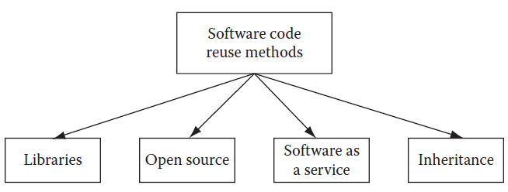 | 4 | 1 | 2 | 2 | 2.5.2
14 | Summarize the Pair Programming.  - Pair programming is a quality driven development technique employed in the eXtreme Programming development model.  - Here, each development task is assigned to two developers.  - While one developer writes the code, the other developer sits behind him and guides him through the requirements (functional, nonfunctional).  - When it is the turn of the other developer to write the code, the first developer sits behind him and guides him on the requirements.  - So developers take turns for the coding and coaching work.  - This makes sure that each developer understands the big picture and helps them to write better code with lesser defects. | 4 | 1 | 3 | 9 | 9.5.3
15 | How exactly does configuration management aid in the case of distributed teams located at far-flung locations with different time zones and a central build is being maintained?  - Configuration management plays an important role in the construction phase.  - Due to changes in requirements and design, an already developed source code needs to be changed.  - So it happens that the development team ends up with many versions of a source code during the project.  - If the version control management is not handled properly, then many developers may start working on a wrong version of source code, and thus a lot of rework may be needed in the end.  - There is one more dimension to configuration management for the construction phase.  - During construction, many software builds are maintained for different versions of the product being developed.  - These builds can break if a bad piece of code is checked into the build by any developer.  - When the build is broken, then no other developer can check in his code.  Thus, development is halted until the build is rebuilt with the correct | 4 | 2 | 3 | 4 | 4.5.1

Part – C (2 x 12 =24 Marks)

Answer all
16.a. | (i) Design an E-R diagram for keeping track of the exploits of your favorite sports team. You should store the matches played, the scores in each match, the players in each match, and individual player statistics for each match. Summary statistics should be modeled as derived attributes. (6 marks)  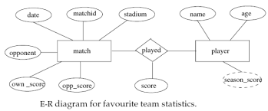  (ii) Draw a use case diagram for the airline reservation system (6 marks)  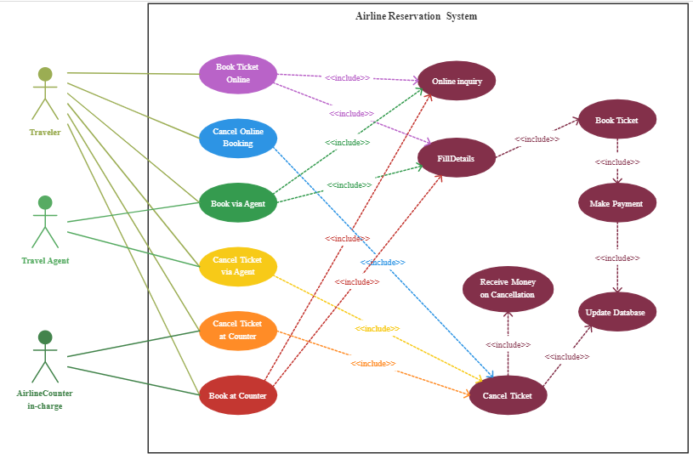 | 12 | 3 | 2 | 3 | 5.4.2

or
16.b. | Discuss Object Oriented Component level design with suitable examples. Give the analysis model and elaborate design class for at least two components in the design.  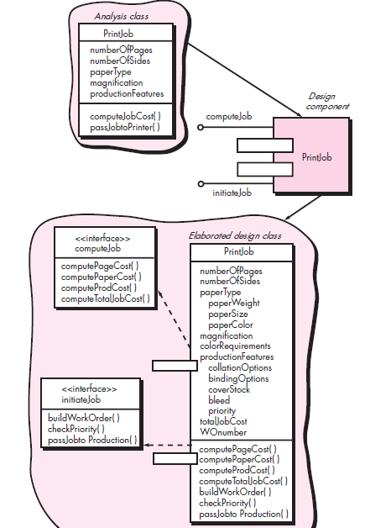 | 12 | 3 | 2 | 3 | 2.5.2
17.a. | Explain the different techniques to predict the quality of the software under construction.  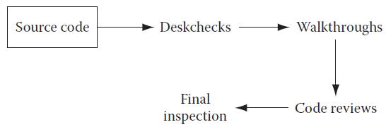 | 12 | 2 | 3 | 3 | 2.3.1

or
17.b. | Elucidate the Software Construction and give the characteristics of the Software Construction in detail  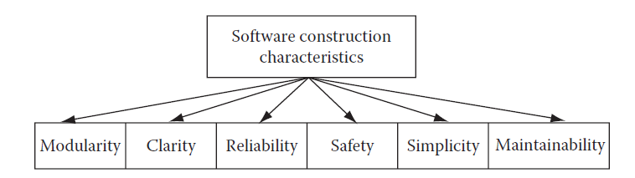 | 12 | 2 | 3 | 3 | 2.3.1

*Performance Indicators are available separately for Computer Science and Engineering in AICTE examination reforms policy.

Course Outcome (CO) and Bloom’s level (BL) Coverage in Questions

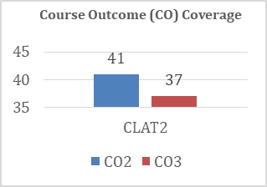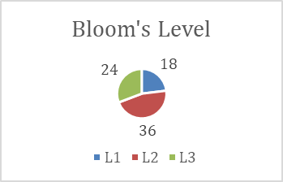

Approved by the Audit Professor/Course Coordinator

